**MODULE 2 – PL/SQL PROGRAMMING**

**Exercise 1: Control Structures**

**Scenario 1:** The bank wants to apply a discount to loan interest rates for customers above 60 years old.

**Code**

CREATE TABLE customers (

customer_id NUMBER PRIMARY KEY,

dob DATE

);

CREATE TABLE loans (

loan_id NUMBER PRIMARY KEY,

customer_id NUMBER,

interest_rate NUMBER(5,2),

FOREIGN KEY (customer_id) REFERENCES customers(customer_id)

);

INSERT INTO customers VALUES (1, TO_DATE('1950-03-15', 'YYYY-MM-DD'));

INSERT INTO customers VALUES (2, TO_DATE('1985-06-25', 'YYYY-MM-DD'));

INSERT INTO loans VALUES (101, 1, 9.5);

INSERT INTO loans VALUES (102, 2, 8.5);

COMMIT;

SET SERVEROUTPUT ON;

DECLARE

v_age NUMBER;

CURSOR cur_discount IS

SELECT c.customer_id, c.dob, l.loan_id, l.interest_rate

FROM customers c

JOIN loans l ON c.customer_id = l.customer_id;

BEGIN

FOR rec IN cur_discount LOOP

v_age := TRUNC(MONTHS_BETWEEN(SYSDATE, rec.dob) / 12);

IF v_age > 60 THEN

UPDATE loans

SET interest_rate = rec.interest_rate * 0.99

WHERE loan_id = rec.loan_id;

DBMS_OUTPUT.PUT_LINE('Discount applied to Loan ID: ' || rec.loan_id ||

' | Age: ' || v_age ||

' | New Interest: ' || (rec.interest_rate * 0.99));

END IF;

END LOOP;

COMMIT;

END;

/

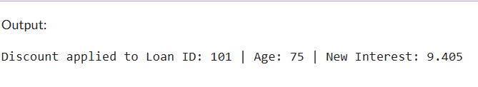

**Scenario 2: A customer can be promoted to VIP status based on their balance.**

**Code**

CREATE TABLE customers (

customer_id NUMBER PRIMARY KEY,

customer_name VARCHAR2(100),

balance NUMBER(10, 2),

isvip VARCHAR2(5) DEFAULT 'FALSE'

);

INSERT INTO customers VALUES (1, 'Uma', 10500.00, 'FALSE');

INSERT INTO customers VALUES (2, 'Arun', 12000.00, 'FALSE');

INSERT INTO customers VALUES (3, 'Vigna', 8000.00, 'FALSE');

INSERT INTO customers VALUES (4, 'Anna', 15000.00, 'FALSE');

INSERT INTO customers VALUES (5, 'Emma', 1000.00, 'FALSE');

COMMIT;

DECLARE

v_balance NUMBER;

CURSOR cur_customers IS

SELECT customer_id, balance

FROM customers;

BEGIN

FOR rec IN cur_customers LOOP

v_balance := rec.balance;

IF v_balance > 10000 THEN

UPDATE customers

SET isvip = 'TRUE'

WHERE customer_id = rec.customer_id;

DBMS_OUTPUT.PUT_LINE('Customer ID ' || rec.customer_id ||

' promoted to VIP | Balance: ' || v_balance);

END IF;

END LOOP;

COMMIT;

END;

/

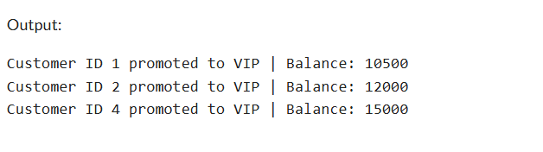

**Scenario 3: The bank wants to send reminders to customers whose loans are due within the next 30 days.**

**Code**

CREATE TABLE customers (

customer_id NUMBER PRIMARY KEY,

customer_name VARCHAR2(100)

);

CREATE TABLE loans (

loan_id NUMBER PRIMARY KEY,

customer_id NUMBER,

due_date DATE,

FOREIGN KEY (customer_id) REFERENCES customers(customer_id)

);

INSERT INTO customers VALUES (1, 'Akash');

INSERT INTO customers VALUES (2, 'kiran');

INSERT INTO customers VALUES (3, 'Jannet');

INSERT INTO loans VALUES (201, 1, SYSDATE + 15);

INSERT INTO loans VALUES (202, 2, SYSDATE + 40);

INSERT INTO loans VALUES (203, 3, SYSDATE + 5);

COMMIT;

SET SERVEROUTPUT ON;

DECLARE

CURSOR cur_due_loans IS

SELECT c.customer_id, c.customer_name, l.loan_id, l.due_date

FROM customers c

JOIN loans l ON c.customer_id = l.customer_id

WHERE l.due_date BETWEEN SYSDATE AND SYSDATE + 30;

BEGIN

FOR rec IN cur_due_loans LOOP

DBMS_OUTPUT.PUT_LINE('Reminder: Loan ID ' || rec.loan_id ||

' for customer ' || rec.customer_name ||

' is due on ' || TO_CHAR(rec.due_date, 'DD-MON-YYYY'));

END LOOP;

END;

/

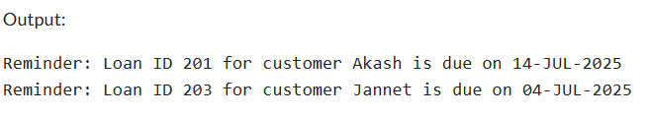

**Exercise 3: Stored Procedures**

**Scenario 1: The bank needs to process monthly interest for all savings accounts.**

**Code**

SET SERVEROUTPUT ON;

CREATE TABLE accounts (

account_id NUMBER PRIMARY KEY,

account_type VARCHAR2(20),

balance NUMBER(10, 2)

);

INSERT INTO accounts VALUES (101, 'savings', 10000);

INSERT INTO accounts VALUES (102, 'current', 20000);

INSERT INTO accounts VALUES (103, 'savings', 5000);

INSERT INTO accounts VALUES (104, 'savings', 15000);

INSERT INTO accounts VALUES (105, 'current', 8000);

COMMIT;

CREATE OR REPLACE PROCEDURE ProcessMonthlyInterest IS

BEGIN

UPDATE accounts

SET balance = balance * 1.01

WHERE LOWER(account_type) = 'savings';

DBMS_OUTPUT.PUT_LINE(SQL%ROWCOUNT || ' savings accounts updated.');

COMMIT;

END;

/

BEGIN

ProcessMonthlyInterest;

END;

/

BEGIN

FOR rec IN (SELECT account_id, account_type, balance FROM accounts ORDER BY account_id) LOOP

DBMS_OUTPUT.PUT_LINE('Account ID: ' || rec.account_id ||

' | Type: ' || rec.account_type ||

' | New Balance: ' || rec.balance);

END LOOP;

END;

/

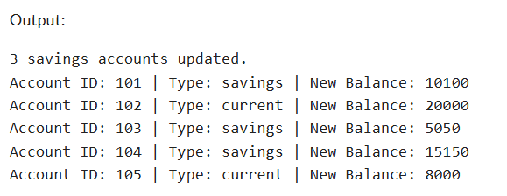

**Scenario 2: The bank wants to implement a bonus scheme for employees based on their performance.**

**Code**

SET SERVEROUTPUT ON;

CREATE TABLE employees (

employee_id NUMBER PRIMARY KEY,

employee_name VARCHAR2(100),

department VARCHAR2(50),

salary NUMBER(10, 2)

);

INSERT INTO employees VALUES (1, 'Alice', 'HR', 50000);

INSERT INTO employees VALUES (2, 'Bob', 'IT', 60000);

INSERT INTO employees VALUES (3, 'Charlie', 'HR', 55000);

INSERT INTO employees VALUES (4, 'David', 'Finance', 70000);

INSERT INTO employees VALUES (5, 'Eve', 'IT', 65000);

COMMIT;

CREATE OR REPLACE PROCEDURE UpdateEmployeeBonus (

p_department IN VARCHAR2,

p_bonus_percent IN NUMBER

) IS

BEGIN

UPDATE employees

SET salary = salary + (salary * p_bonus_percent / 100)

WHERE LOWER(department) = LOWER(p_department);

DBMS_OUTPUT.PUT_LINE(SQL%ROWCOUNT || ' employees in ' || p_department ||

' department received a bonus of ' || p_bonus_percent || '%.');

COMMIT;

END;

/

BEGIN

UpdateEmployeeBonus('IT', 10);

END;

/

BEGIN

FOR rec IN (SELECT * FROM employees ORDER BY employee_id) LOOP

DBMS_OUTPUT.PUT_LINE('ID: ' || rec.employee_id ||

' | Name: ' || rec.employee_name ||

' | Dept: ' || rec.department ||

' | Salary: ' || rec.salary);

END LOOP;

END;

/

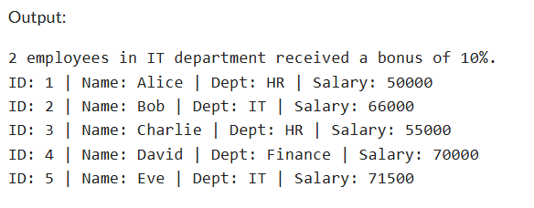

**Scenario 3: Customers should be able to transfer funds between their accounts.**

**Code**

SET SERVEROUTPUT ON;

CREATE TABLE accounts (

account_id NUMBER PRIMARY KEY,

customer_id NUMBER,

balance NUMBER(10, 2)

);

INSERT INTO accounts VALUES (1001, 1, 5000);

INSERT INTO accounts VALUES (1002, 1, 3000);

INSERT INTO accounts VALUES (1003, 2, 7000);

COMMIT;

CREATE OR REPLACE PROCEDURE TransferFunds (

p_source_account IN NUMBER,

p_target_account IN NUMBER,

p_amount IN NUMBER

) IS

v_source_balance NUMBER;

BEGIN

SELECT balance INTO v_source_balance

FROM accounts

WHERE account_id = p_source_account;

IF v_source_balance < p_amount THEN

DBMS_OUTPUT.PUT_LINE('Transfer failed: Insufficient balance in source account.');

ELSE

UPDATE accounts

SET balance = balance - p_amount

WHERE account_id = p_source_account;

UPDATE accounts

SET balance = balance + p_amount

WHERE account_id = p_target_account;

COMMIT;

DBMS_OUTPUT.PUT_LINE('Transfer successful: ' || p_amount ||

' transferred from account ' || p_source_account ||

' to account ' || p_target_account);

END IF;

EXCEPTION

WHEN NO_DATA_FOUND THEN

DBMS_OUTPUT.PUT_LINE('Transfer failed: One or both account IDs not found.');

WHEN OTHERS THEN

DBMS_OUTPUT.PUT_LINE('Transfer failed: ' || SQLERRM);

END;

/

BEGIN

TransferFunds(1001, 1002, 2000);

END;

/

BEGIN

FOR rec IN (SELECT account_id, balance FROM accounts ORDER BY account_id) LOOP

DBMS_OUTPUT.PUT_LINE('Account ID: ' || rec.account_id ||

' | Balance: ' || rec.balance);

END LOOP;

END;

/

